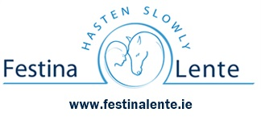

Events Refund Policy

As a non-profit organisation, all profits generated from our events go directly toward supporting our mission which is to provide a unique range of equestrian and horticultural learning, training and employment opportunities that focuses on social inclusion, choice, and personal development.
The costs of planning our events are committed in advance to plan and deliver our activities. For this reason, we do not offer refunds once a payment has been made.
We genuinely appreciate your support and encourage you to contact us before making a payment if you have any questions or need clarification on an event.
However, should unforeseen circumstances such as illness or family emergencies occur, please reach out to us by emailing us at events@festinalente.ie and we will review your refund request.
Please note this refund policy does not affect your statutory rights under European Union consumer protection law. However, please note event tickets for a certain date and time are an exception to automatic refunds. If an event is cancelled by Festina Lente full refunds will be given.
Thank you for supporting Festina Lente, our event helps make our important our work possible.

